Mi Gao

Student Email

Assignment 1

MET CS 779 Assignment 1

MET CS 779 Assignment 1

Table of Contents

1. Introduction 2

2. Question 1 2

1) Part 1 2

2) Part 2 2

1) Part 3 3

3. Question 2 3

1) Part 1 4

4. Question 3 4

2) Part 1 4

3) Part 2 5

5. Conclusion 5

5. Revision History 6

# Introduction

This assignment’s answers has been ordered as same sequence of the question on the assignment. And all ERD screenshots has been stored in ZIP file also.

# Question 1

## Part 1

Anomalies can be created anywhere.

For example, if deleting the bike a customer has rented can create anomalies because everything is in one single cell. Also, status and time period of rental has been stored in same attribute; this will cause the problem when editing the rental info.



## Part 2

Separating user information into Customers, contact information, address, zip code, city and state multiple entities can eliminate the anomaly of the customer's address when editing the same information in all records; it can also better record preferences. In addition, creating separate consumption records, Orders, Bikes, and Parts entities can eliminate anomalies that may occur when updating information. The payment entity will solve the trouble that the payment status is difficult to confirm. At the same time, distinguish Rental and Repair; this will enable them to better grasp their respective Status. For independent Parts entities, it is now possible to determine whether they are hot-selling parts through monthly sales and set special labels.

|  |  |
| --- | --- |
| **Entities** | **Description** |
| Customers | Include basic information of customers |
| Contact_Info | Include primary phone and email info in different attributes |
| Riding_Preferences | Include any type of preferences |
| Address | Include address ID, address_line1, address_line2, and zipcode |
| Address_Bridge | Include each records of address and will not effect others |
| Postcode | Include zipcode, city ID and state ID |
| City | Include city ID and city name |
| State | Include state ID and state name |
| Order_History | Include customer ID, Order ID, Date, and Payment info |
| Payment | Include payment ID, the type of how they paid, the status of payment processing, and cost of the order |
| Rental_Order | Include order ID, Bike ID, how long they rent, and the status of rental processing |
| Repair_Order | Include order ID, Bike ID, how long they rent, and the status of repair processing so people can know how the repair be done or not |
| Bikes | Include bike ID, brand ID, nickname, when it acquired, and the cost for rental |
| Parts | Include Part ID, brand ID, name, how many it has been expended per month, how many left in stock, and the cost |
| Bike_Brands | Include the brand ID, brand name, and type ID |
| Part_Types | Include the brand ID, brand name, and type ID |
| Bike_Brands | Include the type ID, and type name |
| Part_ Types | Include the type ID, type name, and whether it is special or not |

## Part 3

Parts and Bikes have similar design and they are not BCNF because there is no pretty much needed to normalize to be BCNF and educe efficiency of searching data from other entities. For example, in Parts table, the time_repair and stocks are not been set in unique tables for avoiding anomalies. However, we also need the cost of time for repairing and things such as stock and the costs, otherwise, we will need to process through more tables for each specific attributes.

# Question 2

## Part 1

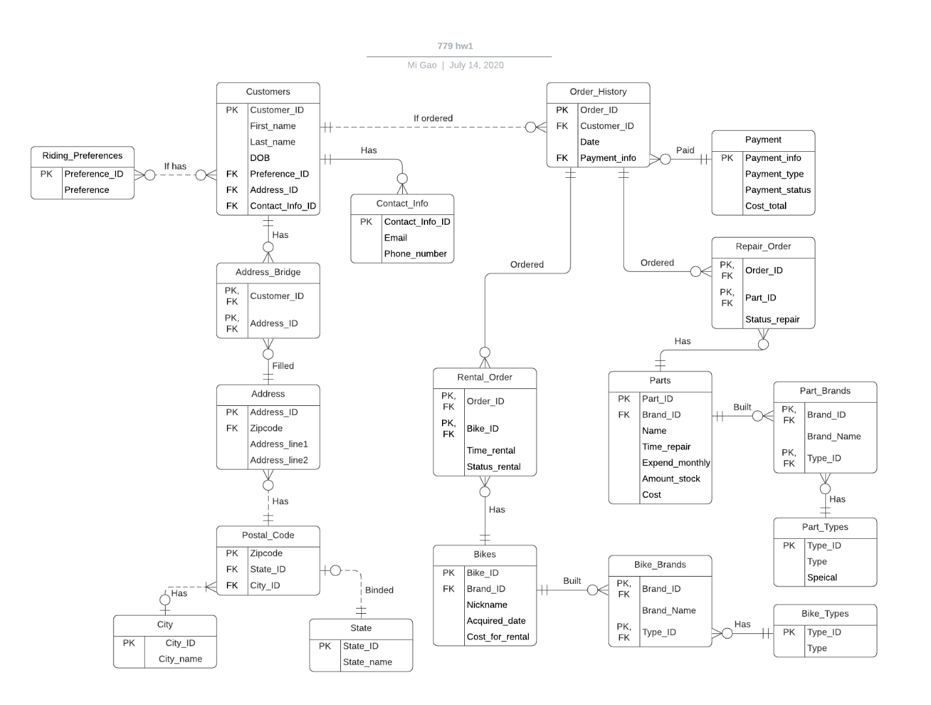

# Question 3

## Part 1

Add three tables called Employees, Jobs, Repair_Department, and Sales_Department. There has specific job for employees, and each job work belongs to either Sales or Repair department. Also, each department’s table will record what job title takes charge of selling what kind of bike or repairing what kind of parts. Therefore, based on how Rental_Order and Repair_Order tables work, this will show the same functionality to differentiate the duties in different jobs.

## Part 2

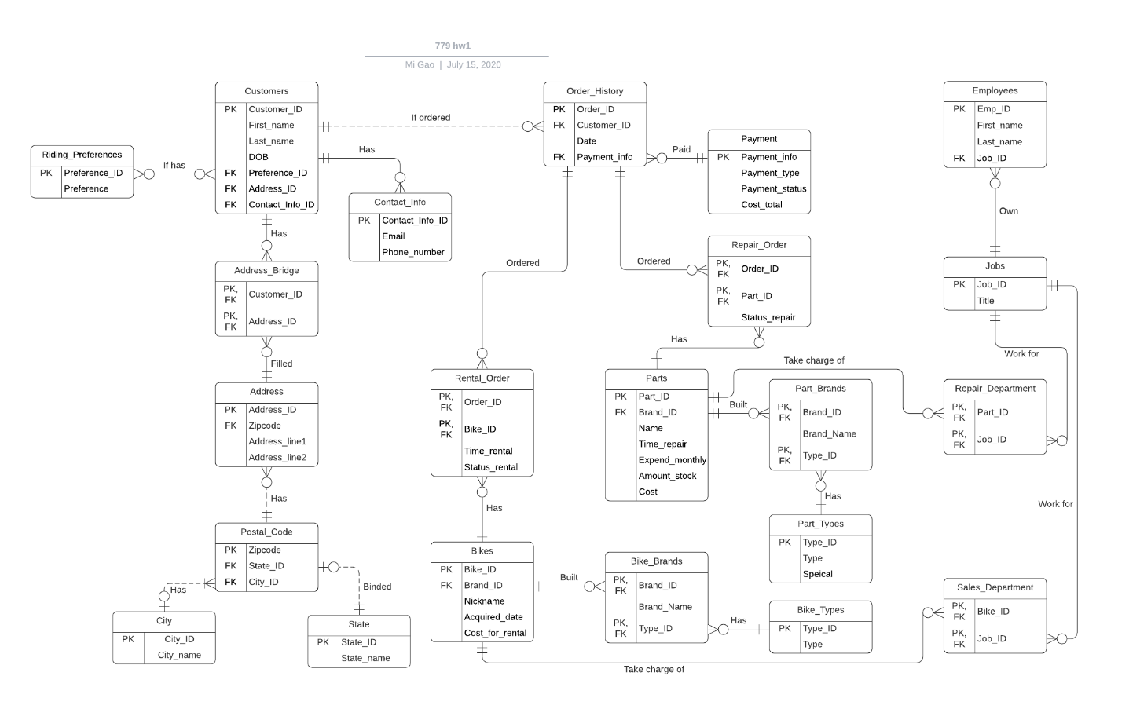

# Conclusion

In this assignment, it made me learn a lot about 3NF and BCNF. I felt that I may still need to be trained more on part of BCNF.

# 5. Revision History

A history of things you added and why, not required but nice to have.

|  |  |  |  |
| --- | --- | --- | --- |
| **Name** | **Date** | **Version** | **Description** |
| Mi Gao | 07/14/19 | 1.0 | Initial Document Creation |
| Mi Gao | 07/15/19 | 1.1 | Fixed some issues |